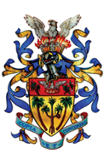
Municipal Council of Vacoas/Phoenix
Welfare Department

Users are informed that renewal processes for Badminton at Palmerstone Municipal Complex will take place as from the 16th March till the 31st March 2020 from 9 am to noon.
By Order.

