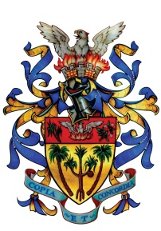

**MUNICIPAL COUNCIL OF VACOAS/PHOENIX**

**in collaboration with**



**Vacoas/Phoenix Regional Petanque Committe**

WINNER

Rs 10,000 + Cups

4th Place – Rs 3,000 + Cups

**Open Vacoas/Phoenix**

**(Doublette – Hommes)**

**Sunday 29th May 2016 as from 9.00 am at the Municipal Yard**

**Registration: From 9 am To 9.30 am at Maisons des Loisirs, Municipal Yard on the same day**

**Tournament reserved for residents of Vacoas/Phoenix only**